Assignment 3
How does Layer Normalization differ from Batch Normalization, and when is each preferred?
Batch-dimension versus feature-dimension normalization
Malik Muhammad Abdullah Hassan - 02621070
5-11-2026

Contents
Table of Figures 1
Motivation 2
Background 2
Main Analysis 3
Normalization axes: batch versus feature 3
Why Batch Normalization is sensitive to batch size 4
Why Layer Normalization is batch-invariant 4
Practical implications: when to choose each 4
Experimental Verification 5
Experiment 1: Image classification (sklearn digits) 5
Experiment 2: Sequence classification (binary majority) 7
Interpretation 8
Conclusion 9
Appendix References 10
Program Code 10
AI Log 16
Further Results and Materials 17

Table of Figures
Figure 1: Conceptual diagram of Batch versus Layer Normalization axes. Each cell is one scalar activation in a layer. The highlighted region shows which activations are pooled together 3
Figure 2: Test accuracy as a function of batch size for each normalization variant on the sklearn digits CNN. Error bars show one standard deviation across two seeds. 6
Figure 3: Training loss curves at batch sizes 4 and 64. At batch size 4, BatchNorm trains noisily; at batch size 64, all three methods converge smoothly. 6
Figure 4: Test accuracy on the binary-majority task for each normalization variant at three batch sizes. The dashed line marks chance (0.5). 7
Figure 5: Training loss curves on the binary-majority task at batch sizes 4, 16, and 64. BatchNorm shows visibly slower and noisier convergence at small batch. 8

Table 1: Strengths and limitations of Batch and Layer Normalization 5
Table 2: Experiment 1 — Test accuracy by normalization and batch size. 6
Table 3: Experiment 2 — Test accuracy by normalization and batch size. 8

Motivation
Normalization layers are now considered an essential component of nearly every deep neural network. Batch Normalization was the breakthrough method for decreasing the error in NN training, and it is discussed in detail within the lecture slides. Layer Normalization, however is delegated to a short discussion. This may point to the fact that one is more important than the other but this premise is worth investigating. The question this report investigates is why the practical default flips between the two methods depending on the architecture and the data, and what theoretical properties drive that choice. The question is interesting because the two methods look almost identical on paper, both subtracting a mean and dividing by a standard deviation, yet they behave very differently in practice, with each having its own strengths and weaknesses.

Background
Both Batch Normalization (BN) and Layer Normalization (LN) follow the same three-step template: compute a mean and variance over some axis of the input, standardize the input using those statistics, and apply a learnable affine transform (a scale $γ$ and shift $β$) so the network can recover any distribution it needs. They differ only in which axis the statistics are taken over.
Let us define both operations with a normalization layer input $x$, where $B$ is the mini-batch size and $D$ is the feature dimension. Batch Normalization computes per-feature statistics across the batch:
$$μ_{j}=\frac{1}{B}\sum_{i=1}^{B}{x_{ij}}, σ_{j}^{2}=\frac{1}{B}\sum_{i=1}^{B}{{\left(x_{ij}-μ_{j}\right)}^{2}}$$
$${\hat{x}}_{ij}=\frac{x_{ij}-μ_{j}}{\sqrt{σ_{j}^{2}+ε}}, y_{ij}=γ{\hat{x}}_{ij}+β$$
At test time, BN replaces the per-batch statistics with running averages estimated during training, so the same input always produces the same output. This requires the network to be told whether it is in training or evaluation mode.
Layer Normalization swaps the axis. The mean and variance are taken across the feature dimension, separately for each individual sample in the batch:
$$μ_{i}=\frac{1}{D}\sum_{j=1}^{D}{x_{ij}}, σ_{i}^{2}=\frac{1}{D}\sum_{j=1}^{D}{{\left(x_{ij}-μ_{i}\right)}^{2}}$$
$${\hat{x}}_{ij}=\frac{x_{ij}-μ_{i}}{\sqrt{σ_{i}^{2}+ε}}, y_{ij}={γ\hat{x}}_{ij}+β$$
Because each sample is normalized independently, the computation at training and inference time is identical — there is no train/eval mode to switch between, and no running averages to maintain.
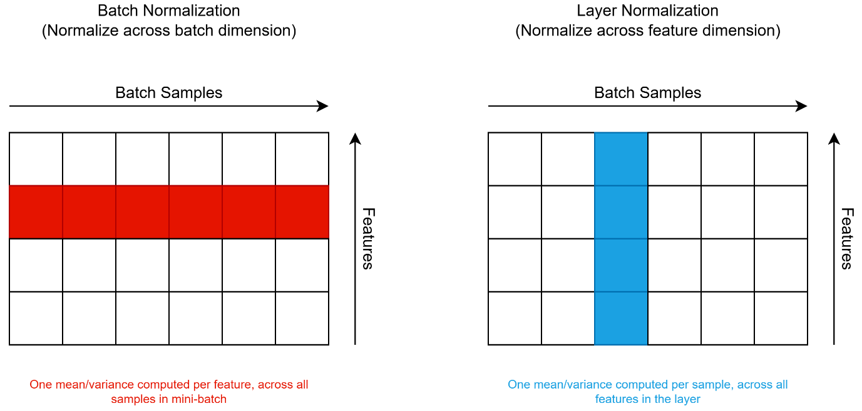
Figure 1: Conceptual diagram of Batch versus Layer Normalization axes. Each cell is one scalar activation in a layer. The highlighted region shows which activations are pooled together
Figure 1 visualizes the two axes. In Batch Normalization a single mean and variance are shared across all samples in the mini-batch for one fixed feature. In Layer Normalization a single mean and variance are shared across all features in the layer for one fixed sample. This single change of axis is the root of every property that distinguishes the two methods.

Main Analysis
The two methods share a structure, but the axis they normalize over has three consequences that determine where each one is preferred: (1) batch-size dependence, (2) train/test symmetry, and (3) applicability to architectures with variable structure such as recurrent networks. Each is discussed below, followed by the practical implications for choosing between the two.

Normalization axes: batch versus feature
In Batch Normalization the statistics depend on every other sample in the mini-batch. If the batch is large and representative, the statistics are an accurate proxy for the population statistics that the network is implicitly targeting. If the batch is small or atypical, the statistics are noisy estimators, and every activation in the layer is shifted and rescaled by that noise before propagating forward.
In Layer Normalization the statistics depend only on the features of the current sample. They are deterministic functions of a single forward pass, with no dependence on any other input, so there is no notion of "batch noise" at all. The trade-off is that the statistics no longer reflect a population — instead, they are a property of each sample's activation profile.

Why Batch Normalization is sensitive to batch size
The mini-batch mean is an unbiased estimator of the population mean of the pre-activation: $E[μ̂]=μ$. However, the variance of that estimator scales as $Var[μ̂]=σ² / B$. At $B=2$ the standard error of the estimate is roughly 71% of $σ$; at $B=128$ it has dropped to about 9% of $σ$. The same activation, normalized by these noisy estimates, can be shifted and rescaled wildly from batch to batch, which destabilizes downstream gradient signals. BN's error increases rapidly as the batch size becomes smaller, because the batch statistics become inaccurate.
A second, related issue is the train-versus-test asymmetry. BN computes batch statistics during training but uses running averages at inference. When the batch is small, the running averages are themselves noisy estimates, and the inference behavior can drift away from the training behavior. The sample variance computed with divisor $B$ underestimates the population variance, so an unbiased estimate uses divisor $(B-1)$ instead:
$$σ_{biased}^{2}=\frac{1}{B}\sum_{i}^{B}{{\left(x_{i}-\hat{μ}\right)}^{2}}, σ_{unbiased}^{2}=\frac{1}{B-1}\sum_{i}^{B}{{\left(x_{i}-\hat{μ}\right)}^{2}}$$
The bias factor $(B-1)/B$ is 0.50 at $B=2$ and 0.99 at $B=128$, which is another batch size effect that compounds with the variance-of-the-mean noise above.

Why Layer Normalization is batch-invariant
Layer Normalization sidesteps both of these problems. Because the normalization is computed within a single sample, the batch size is irrelevant to the statistics. The same input produces the same output regardless of how many other samples are in the batch with it. The cost is that LN no longer has access to the across-sample population information that BN exploits when batches are large.
A second consequence concerns architectures with variable structure. Recurrent networks share weights across timesteps. If we attempt to apply BN at each recurrent step, we have to maintain a separate set of running statistics for each timestep, and the per-step batch statistics are even noisier than in a feed-forward network. Sequences of different lengths break the bookkeeping entirely. LN has no such issue: it computes one (mean, variance) pair per sample per timestep, with no batch dependence and no per-timestep state.

Practical implications: when to choose each
The two failure modes lead to opposite practical defaults in modern deep learning. Batch Normalization is the standard choice for image classification with CNNs, where mini-batches of 32 to 256 are common, each batch contains independent samples drawn from the same distribution, and the across-sample statistics carry useful regularizing noise.
Layer Normalization is the standard choice for Transformers and other sequence models. The reasons are the ones above: sequences are variable in length, batches are often small due to memory constraints, and the per-timestep statistics that BN would need are not reliable.
Property | Batch Normalization | Layer Normalization
Axis of normalization | across batch samples, per feature | across features, per sample
Batch-size dependence | strong; statistics become noisy when B is small | none; statistics are computed within one sample
Train/test behavior | asymmetric — running averages at inference | symmetric — identical at train and test
Sequence / variable-length inputs | awkward; needs per-timestep running stats and breaks for variable T | natural; per-sample statistics computed independently at each timestep
Implicit regularization | present, from across-batch noise (Wu & He, 2018) | absent; LN does not introduce mini-batch noise
Table 1: Strengths and limitations of Batch and Layer Normalization

Experimental Verification
Two small experiments were run to test the theoretical predictions. The first targets BN's advantage on image classification with a CNN at varying batch sizes. The second targets LN's advantage on a sequence-classification task with normalization applied inside the recurrence. The full program code is in the appendix.

Experiment 1: Image classification (sklearn digits)
The task is ten-way digit classification on the scikit-learn digits dataset (1797 grayscale 8×8 images, split 80/20 into 1437 training and 360 test samples). The model is a small convolutional network with two convolutional blocks (8 and 16 channels) and a 32-unit fully-connected head, totaling 9,802 trainable parameters in the no-norm variant (BN adds 112 affine parameters; LN adds 1,600 because LN keeps per-feature-map γ and β at every spatial position). Three variants were compared: no normalization, BatchNorm (BatchNorm2d after each conv layer, BatchNorm1d before the final FC), and LayerNorm (LayerNorm over each feature map and over the FC activations). The optimizer was Adam with fixed learning rate 0.001, and every run was trained for exactly 600 gradient steps so that wall-clock time is bounded and approximately matched across batch sizes. Each (normalization, batch size) configuration was repeated with two random seeds (42 and 123); reported numbers are mean and standard deviation. Batch sizes spanned {2, 4, 8, 16, 32, 64, 128}.
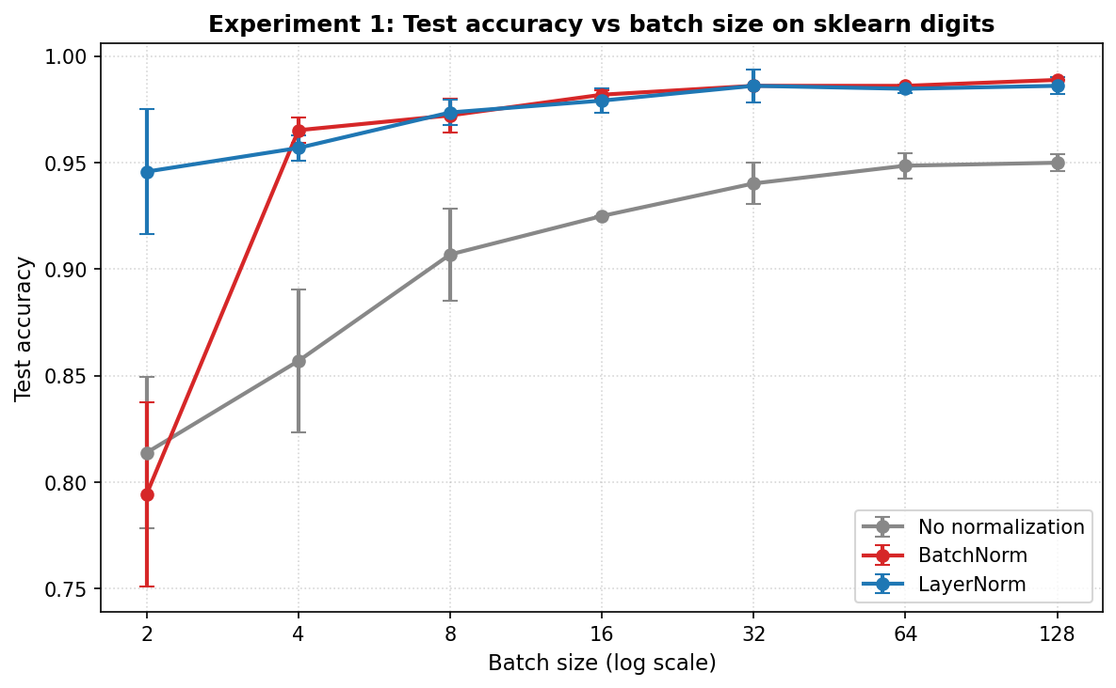
Figure 2: Test accuracy as a function of batch size for each normalization variant on the sklearn digits CNN. Error bars show one standard deviation across two seeds.
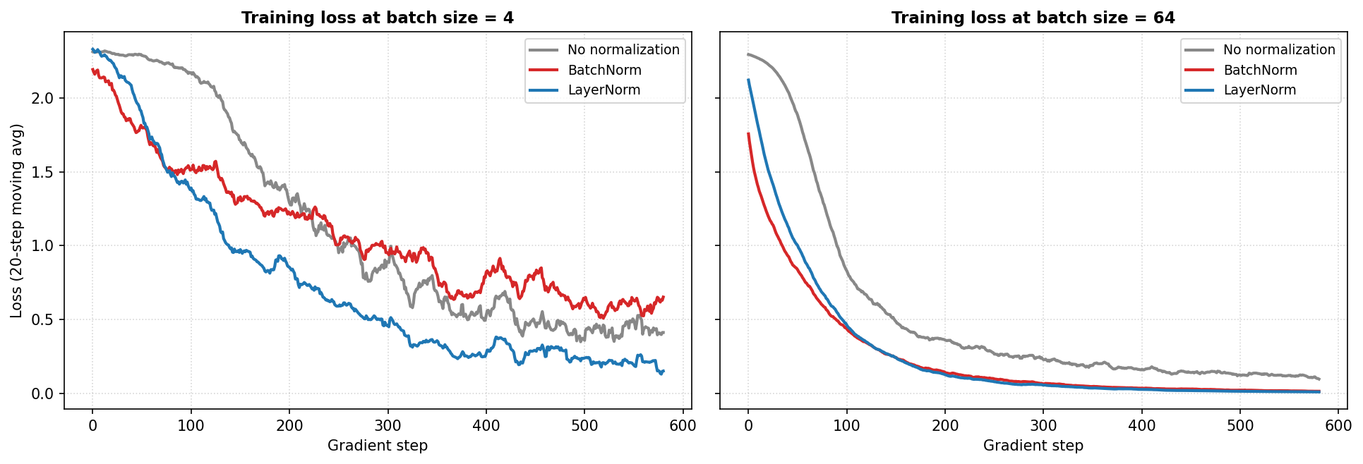
Figure 3: Training loss curves at batch sizes 4 and 64. At batch size 4, BatchNorm trains noisily; at batch size 64, all three methods converge smoothly.
Batch size | No-norm | BatchNorm | LayerNorm
2 | 0.814 ± 0.035 | 0.794 ± 0.043 | 0.946 ± 0.029
4 | 0.857 ± 0.033 | 0.965 ± 0.006 | 0.957 ± 0.006
8 | 0.907 ± 0.022 | 0.972 ± 0.008 | 0.974 ± 0.006
16 | 0.925 ± 0.000 | 0.982 ± 0.002 | 0.979 ± 0.006
32 | 0.940 ± 0.010 | 0.986 ± 0.000 | 0.986 ± 0.008
64 | 0.949 ± 0.006 | 0.986 ± 0.000 | 0.985 ± 0.002
128 | 0.950 ± 0.004 | 0.989 ± 0.000 | 0.986 ± 0.004
Table 2: Experiment 1 — Test accuracy by normalization and batch size.
With no normalization (gray), accuracy rises from 0.81 at batch size 2 to 0.95 at batch size 128, consistent with the standard observation that smaller batches mean noisier gradients and slower learning. BatchNorm (red) shows the opposite trend at the extreme: at batch size 2 it drops to 0.79, worse than the no-normalization baseline. As soon as the batch size reaches 4 it recovers to 0.97, and at batch size 128 it is the strongest method at 0.99. LayerNorm (blue) is remarkably flat: 0.95 at batch size 2 and 0.99 at batch size 128. Across the entire sweep, LN never drops below 0.94.

Experiment 2: Sequence classification (binary majority)
The second experiment is designed to expose normalization choices inside a recurrent computation. The task is binary majority: given a sequence of 8 random bits, predict whether the count of 1s exceeds 4. Cases with exactly four 1s are removed to keep the labels unambiguous. The training set is 4,000 sequences; the test set is 1,000. The model is a custom Elman-style RNN with a 16-dimensional embedding and a 32-dimensional hidden state. Normalization is applied inside the recurrence at every timestep.
For BatchNorm, the statistics are collected across the batch dimension at every timestep. For LayerNorm, the statistics are collected across the hidden-feature dimension per sample per timestep. Each configuration was trained for 800 gradient steps with Adam at learning rate 0.002 and two seeds. Batch sizes were {4, 16, 64}.
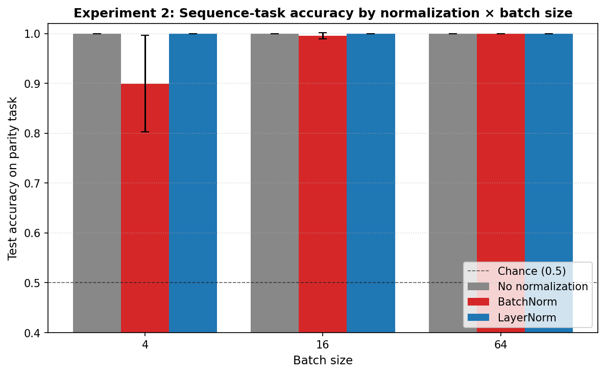
Figure 4: Test accuracy on the binary-majority task for each normalization variant at three batch sizes. The dashed line marks chance (0.5).
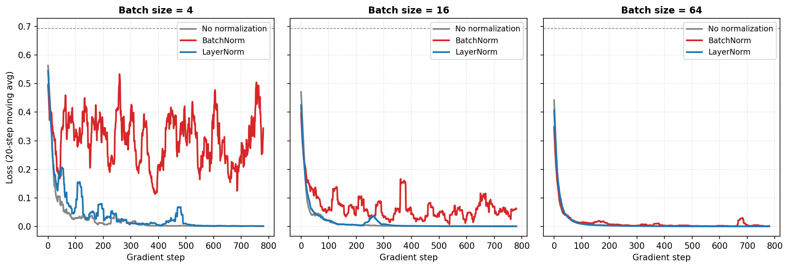
Figure 5: Training loss curves on the binary-majority task at batch sizes 4, 16, and 64. BatchNorm shows visibly slower and noisier convergence at small batch.
Batch size | No-norm | BatchNorm | LayerNorm
4 | 1.000 ± 0.000 | 0.900 ± 0.097 | 1.000 ± 0.000
16 | 1.000 ± 0.000 | 0.996 ± 0.006 | 1.000 ± 0.000
64 | 1.000 ± 0.000 | 1.000 ± 0.000 | 1.000 ± 0.000
Table 3: Experiment 2 — Test accuracy by normalization and batch size.
The task is easy enough that the no-normalization baseline reaches 1.00 at every batch size. LayerNorm matches the baseline exactly at every batch size — its per-sample statistics are completely invariant to how the mini-batch is composed. BatchNorm, in contrast, drops to 0.90 at batch size 4 with a large standard deviation of 0.10, indicating that the training is unstable across seeds. At batch size 16 it recovers most of the way to 0.996, and at batch size 64 it reaches 1.00. The same task that a 1,666-parameter RNN with no normalization solves perfectly at every batch size becomes hard for BatchNorm when there are only four samples in the batch.
Interpretation
Both experiments give a consistent picture and align with the theoretical predictions. BatchNorm has a clearly visible small-batch failure mode in both settings. On the image task it underperforms not only LayerNorm but even the no-normalization baseline at batch size 2. On the sequence task it underperforms at batch size 4 by ten percentage points despite the task being trivially solvable by the unnormalized baseline. The per-feature statistics that BN relies on are too noisy when only a handful of samples contribute to them. In the sequence experiment the problem is amplified because BN re-computes those noisy statistics at every recurrent timestep, and the noise compounds across the sequence.
LayerNorm shows the opposite pattern. In Experiment 1 its accuracy spans a narrow range from 0.95 at batch size 2 to 0.99 at batch size 128; in Experiment 2 it is exactly 1.00 at every batch size. The per-sample statistics do not interact with the mini-batch composition, so LN simply does not have the same failure mode. The trade-off is visible only at the large-batch end of Experiment 1: at batch size 128, BN edges LN by about 0.3 percentage points, reflecting that with enough samples the across-batch statistics of BN encode useful regularizing noise that LN does not have access to.
The result that the no-normalization baseline matches LN on the sequence task is worth noting. It indicates that LN's advantage in that experiment is not about improving over an already-working baseline; it is about avoiding the failure that BN introduces.
The $B=2$ result in Experiment 1 deserves a closer look because it is the most striking single number in the report. With only two samples per mini-batch, the sample variance has just one degree of freedom: Bessel-corrected, it becomes the squared deviation of one sample from the other divided by one. Any unusual pair will produce a small variance estimate, the standardized activation $x̂$ will be inflated, and the downstream gradient signal becomes correspondingly volatile. Each gradient step then updates $γ$ and $β$ based on this volatile signal, creating a feedback loop where the running statistics that BN saves for inference are themselves noisy. The end result is that BN at $B=2$ not only fails to outperform the no-normalization baseline but produces a final training loss roughly an order of magnitude higher than at $B=4$ (1.85 versus 0.65).
One limitation of these experiments is scale. The image task uses 8×8 digits, not photographs, and the sequence task is a deliberately simple majority count rather than a natural-language problem. At larger scale BN is known to provide a regularization benefit on top of its statistical role. Our findings are consistent with that picture but in miniature. A second limitation is that each configuration was repeated with only two random seeds, so the standard-deviation bars in Tables 2-3 are minimum-information estimates; the qualitative patterns (BN dropping sharply at B = 2 in Experiment 1, BN underperforming at B = 4 in Experiment 2) are large compared to the observed run-to-run variation, but a larger seed budget would tighten the confidence intervals.
Conclusion
The two methods normalize the same activations across two different axes, and that single design choice is the cause of every difference between them. Batch Normalization is the right choice when mini-batches are large and homogeneous, the inputs share a stable population distribution, and the regularizing noise from across-batch statistics is useful — the classic image-classification setting. Layer Normalization is the right choice when batches are small, when inputs vary in structure or length, or when the same parameters must be applied repeatedly with no consistent across-sample population to average over — the classic recurrent and Transformer setting. The flip in practical default between CNN-era and Transformer-era architectures tracks the structure of the data more than the architecture itself. Modern systems that use Layer Normalization do so not because LN is generally superior, but because the data and batch regimes they operate in are exactly the ones where BN's mechanism breaks.

Appendix

References
- Ba, J. L., Kiros, J. R., & Hinton, G. E. (2016). Layer normalization. arXiv preprint arXiv:1607.06450.
- Ioffe, S., & Szegedy, C. (2015). Batch normalization: Accelerating deep network training by reducing internal covariate shift. arXiv preprint arXiv:1502.03167.
- Vaswani, A., Shazeer, N., Parmar, N., Uszkoreit, J., Jones, L., Gomez, A. N., Kaiser, Ł., & Polosukhin, I. (2017). Attention is all you need. Advances in Neural Information Processing Systems, 30.
- Wu, Y., & He, K. (2018). Group normalization. arXiv preprint arXiv:1803.08494.
- Xu, J., Sun, X., Zhang, Z., Zhao, G., & Lin, J. (2019). Understanding and improving layer normalization. Advances in Neural Information Processing Systems, 32.

Program Code
import os, time, json
import numpy as np
import pandas as pd
import torch
import torch.nn as nn
import torch.nn.functional as F
import torch.optim as optim
from torch.utils.data import DataLoader, TensorDataset
import matplotlib.pyplot as plt
from sklearn.datasets import load_digits
from sklearn.model_selection import train_test_split

DEVICE = torch.device('cuda' if torch.cuda.is_available() else 'cpu')
print(f'Device: {DEVICE} | PyTorch: {torch.__version__}')

digits = load_digits()
X = digits.images.astype(np.float32) / 16.0 # normalize to [0, 1]
y = digits.target.astype(np.int64)
X = X[:, None, :, :] # add channel dim → (N, 1, 8, 8)

X_train_np, X_test_np, y_train_np, y_test_np = train_test_split(
X, y, test_size=0.2, random_state=0, stratify=y
)
X_train_t = torch.from_numpy(X_train_np)
y_train_t = torch.from_numpy(y_train_np)
X_test_t = torch.from_numpy(X_test_np).to(DEVICE)
y_test_t = torch.from_numpy(y_test_np).to(DEVICE)
print(f'Train: {len(X_train_t)} samples | Test: {len(X_test_t)} samples')

class SmallCNN(nn.Module):
"""Small CNN with selectable normalization layer."""
def __init__(self, norm='none'):
super().__init__()
self.norm_type = norm
self.conv1 = nn.Conv2d(1, 8, kernel_size=3, padding=1)
self.conv2 = nn.Conv2d(8, 16, kernel_size=3, padding=1)
self.pool = nn.MaxPool2d(2)
self.fc1 = nn.Linear(16 * 4 * 4, 32)
self.fc2 = nn.Linear(32, 10)
if norm == 'bn':
self.norm1 = nn.BatchNorm2d(8)
self.norm2 = nn.BatchNorm2d(16)
self.norm_fc = nn.BatchNorm1d(32)
elif norm == 'ln':
self.norm1 = nn.LayerNorm([8, 8, 8])
self.norm2 = nn.LayerNorm([16, 4, 4])
self.norm_fc = nn.LayerNorm(32)
else:
self.norm1 = self.norm2 = self.norm_fc = nn.Identity()

def forward(self, x):
x = self.conv1(x); x = self.norm1(x); x = F.relu(x); x = self.pool(x)
x = self.conv2(x); x = self.norm2(x); x = F.relu(x)
x = x.flatten(1)
x = self.fc1(x); x = self.norm_fc(x); x = F.relu(x)
return self.fc2(x)

print('SmallCNN parameter count:', sum(p.numel() for p in SmallCNN().parameters()))

def train_one_exp1(norm, batch_size, seed, n_steps=600, lr=1e-3):
torch.manual_seed(seed); np.random.seed(seed)
model = SmallCNN(norm=norm).to(DEVICE)
optimizer = optim.Adam(model.parameters(), lr=lr)
criterion = nn.CrossEntropyLoss()

loader = DataLoader(TensorDataset(X_train_t, y_train_t),
batch_size=batch_size, shuffle=True, drop_last=False)
losses = []
model.train()
step = 0
while step < n_steps:
for x, y_ in loader:
if step >= n_steps: break
x, y_ = x.to(DEVICE), y_.to(DEVICE)
if norm == 'bn' and x.size(0) == 1: # BN needs >=2 elements
continue
optimizer.zero_grad()
loss = criterion(model(x), y_)
loss.backward()
optimizer.step()
losses.append(loss.item())
step += 1

model.eval()
with torch.no_grad():
test_acc = (model(X_test_t).argmax(dim=1) == y_test_t).float().mean().item()
return test_acc, losses

SEEDS_1 = [42, 123]
BATCH_SIZES_1 = [2, 4, 8, 16, 32, 64, 128]
NORMS = ['none', 'bn', 'ln']

exp1_results = []
exp1_curves = {}
total = len(NORMS) * len(BATCH_SIZES_1) * len(SEEDS_1)
i = 0
t0 = time.time()
for norm in NORMS:
for bs in BATCH_SIZES_1:
for sd in SEEDS_1:
i += 1
acc, losses = train_one_exp1(norm, bs, sd)
exp1_results.append({'norm': norm, 'batch_size': bs, 'seed': sd,
'test_accuracy': acc,
'final_loss': float(np.mean(losses[-20:]))})
exp1_curves[(norm, bs, sd)] = losses
print(f'[{i:>2}/{total}] norm={norm:5s} bs={bs:>3d} seed={sd:>3d} '
f'acc={acc:.4f}')
print(f'Total: {time.time()-t0:.1f}s')

df1 = pd.DataFrame(exp1_results)
summary1 = df1.groupby(['norm','batch_size'])['test_accuracy'].agg(['mean','std']).round(4)
print('\n=== Experiment 1 — Mean test accuracy ===')
print(summary1)

fig, ax = plt.subplots(figsize=(8, 5))
colors = {'none': '#888888', 'bn': '#d62728', 'ln': '#1f77b4'}
labels = {'none': 'No normalization', 'bn': 'BatchNorm', 'ln': 'LayerNorm'}
for norm in NORMS:
sub = df1[df1.norm == norm].groupby('batch_size')['test_accuracy'].agg(['mean','std'])
ax.errorbar(sub.index, sub['mean'], yerr=sub['std'], marker='o', markersize=6,
linewidth=2, capsize=4, color=colors[norm], label=labels[norm])
ax.set_xscale('log', base=2)
ax.set_xticks(BATCH_SIZES_1); ax.set_xticklabels(BATCH_SIZES_1)
ax.set_xlabel('Batch size (log scale)'); ax.set_ylabel('Test accuracy')
ax.set_title('Experiment 1: Test accuracy vs batch size (sklearn digits CNN)',
fontweight='bold')
ax.legend(loc='lower right'); ax.grid(True, linestyle=':', alpha=0.5)
plt.tight_layout(); plt.show()

fig, axes = plt.subplots(1, 2, figsize=(13, 4.5), sharey=True)
for ax, bs in zip(axes, [4, 64]):
for norm in NORMS:
losses = exp1_curves[(norm, bs, SEEDS_1[0])]
w = 20
smoothed = np.convolve(losses, np.ones(w)/w, mode='valid')
ax.plot(np.arange(len(smoothed)), smoothed, color=colors[norm],
linewidth=2, label=labels[norm])
ax.set_xlabel('Gradient step')
ax.set_title(f'Training loss at batch size = {bs}', fontweight='bold')
ax.grid(True, linestyle=':', alpha=0.5); ax.legend(loc='upper right')
axes[0].set_ylabel('Loss (20-step moving avg)')
plt.tight_layout(); plt.show()

SEQ_LEN = 8
N_TRAIN_2, N_TEST_2 = 4000, 1000

def make_majority_data(n, seq_len, seed):
rng = np.random.RandomState(seed)
x = rng.randint(0, 2, size=(n, seq_len)).astype(np.int64)
s = x.sum(axis=1)
y = (s > seq_len / 2).astype(np.int64)
keep = s != seq_len / 2 # drop exact-half cases (ambiguous)
return torch.from_numpy(x[keep]), torch.from_numpy(y[keep])

X2_train, y2_train = make_majority_data(int(N_TRAIN_2 * 1.3), SEQ_LEN, seed=0)
X2_train, y2_train = X2_train[:N_TRAIN_2], y2_train[:N_TRAIN_2]
X2_test, y2_test = make_majority_data(int(N_TEST_2 * 1.3), SEQ_LEN, seed=1)
X2_test, y2_test = X2_test[:N_TEST_2].to(DEVICE), y2_test[:N_TEST_2].to(DEVICE)
print(f'Train: {X2_train.shape}, Test: {X2_test.shape}')
print(f'Class balance — train: {y2_train.float().mean():.3f}, test: {y2_test.float().mean().item():.3f}')

HIDDEN, EMBED = 32, 16

class CustomRNN(nn.Module):
"""
Manual Elman-style RNN with normalization at each timestep:
h_t = tanh(norm(W_xh x_t + W_hh h_{t-1}))
"""
def __init__(self, vocab=2, embed=EMBED, hidden=HIDDEN, n_classes=2, norm='none'):
super().__init__()
self.embed = nn.Embedding(vocab, embed)
self.W_xh = nn.Linear(embed, hidden)
self.W_hh = nn.Linear(hidden, hidden, bias=False)
self.classifier = nn.Linear(hidden, n_classes)
self.hidden = hidden
if norm == 'bn': self.norm = nn.BatchNorm1d(hidden)
elif norm == 'ln': self.norm = nn.LayerNorm(hidden)
else: self.norm = nn.Identity()

def forward(self, x):
B, T = x.shape
h = torch.zeros(B, self.hidden, device=x.device)
for t in range(T):
pre = self.W_xh(self.embed(x[:, t])) + self.W_hh(h)
h = torch.tanh(self.norm(pre))
return self.classifier(h)

print('CustomRNN parameter count:', sum(p.numel() for p in CustomRNN().parameters()))

def train_one_exp2(norm, batch_size, seed, n_steps=800, lr=2e-3):
torch.manual_seed(seed); np.random.seed(seed)
model = CustomRNN(norm=norm).to(DEVICE)
optimizer = optim.Adam(model.parameters(), lr=lr)
criterion = nn.CrossEntropyLoss()
loader = DataLoader(TensorDataset(X2_train, y2_train),
batch_size=batch_size, shuffle=True, drop_last=True)
losses = []; diverged = False
model.train()
step = 0
while step < n_steps:
for x, y_ in loader:
if step >= n_steps: break
x, y_ = x.to(DEVICE), y_.to(DEVICE)
optimizer.zero_grad()
loss = criterion(model(x), y_)
if torch.isnan(loss) or torch.isinf(loss):
diverged = True; losses.append(float('nan')); break
loss.backward()
torch.nn.utils.clip_grad_norm_(model.parameters(), max_norm=5.0)
optimizer.step()
losses.append(loss.item())
step += 1
if diverged: break
model.eval()
with torch.no_grad():
test_acc = (model(X2_test).argmax(dim=1) == y2_test).float().mean().item()
return test_acc, losses, diverged

SEEDS_2 = [42, 123]
BATCH_SIZES_2 = [4, 16, 64]

exp2_results = []
exp2_curves = {}
i = 0; total = len(NORMS) * len(BATCH_SIZES_2) * len(SEEDS_2)
t0 = time.time()
for norm in NORMS:
for bs in BATCH_SIZES_2:
for sd in SEEDS_2:
i += 1
acc, losses, div = train_one_exp2(norm, bs, sd)
exp2_results.append({'norm': norm, 'batch_size': bs, 'seed': sd,
'test_accuracy': acc,
'final_loss': float(np.nanmean(losses[-20:])),
'diverged': div})
exp2_curves[(norm, bs, sd)] = losses
print(f'[{i:>2}/{total}] norm={norm:5s} bs={bs:>3d} seed={sd:>3d} acc={acc:.4f}')
print(f'Total: {time.time()-t0:.1f}s')

df2 = pd.DataFrame(exp2_results)
summary2 = df2.groupby(['norm','batch_size'])['test_accuracy'].agg(['mean','std']).round(4)
print('\n=== Experiment 2 — Mean test accuracy ===')
print(summary2)

fig, ax = plt.subplots(figsize=(8, 5))
x = np.arange(len(BATCH_SIZES_2)); width = 0.27
for j, norm in enumerate(NORMS):
sub = df2[df2.norm == norm].groupby('batch_size')['test_accuracy'].agg(['mean','std'])
ax.bar(x + (j - 1) * width, sub.loc[BATCH_SIZES_2, 'mean'].values, width,
yerr=sub.loc[BATCH_SIZES_2, 'std'].values, capsize=4,
color=colors[norm], label=labels[norm])
ax.set_xticks(x); ax.set_xticklabels(BATCH_SIZES_2)
ax.set_xlabel('Batch size'); ax.set_ylabel('Test accuracy')
ax.set_title('Experiment 2: Sequence-task accuracy', fontweight='bold')
ax.axhline(0.5, color='black', linestyle='--', linewidth=0.8, alpha=0.6, label='Chance')
ax.set_ylim(0.4, 1.05); ax.legend(loc='lower right'); ax.grid(True, linestyle=':', alpha=0.5, axis='y')
plt.tight_layout(); plt.show()

fig, axes = plt.subplots(1, len(BATCH_SIZES_2), figsize=(13, 4.5), sharey=True)
for ax, bs in zip(axes, BATCH_SIZES_2):
for norm in NORMS:
losses = exp2_curves[(norm, bs, SEEDS_2[0])]
w = 20
if len(losses) >= w and not all(np.isnan(losses[:w])):
smoothed = np.convolve(np.array(losses), np.ones(w)/w, mode='valid')
ax.plot(np.arange(len(smoothed)), smoothed, color=colors[norm], linewidth=2, label=labels[norm])
ax.set_xlabel('Gradient step')
ax.set_title(f'Batch size = {bs}', fontweight='bold')
ax.grid(True, linestyle=':', alpha=0.5); ax.legend(fontsize=9, loc='upper right')
ax.axhline(np.log(2), color='black', linestyle='--', linewidth=0.8, alpha=0.5)
axes[0].set_ylabel('Loss (20-step moving avg)')
plt.tight_layout(); plt.show()

AI Log
The following screenshots show the prompts used during the writing of this paper. The complete response has been cut for brevity.




Further Results and Materials
In Experiment 1, the BatchNorm runs at batch size 2 have a final loss around 1.85 (much higher than other configurations), indicating that the optimization is genuinely unstable rather than just slow. The final loss drops by more than an order of magnitude as soon as batch size reaches 4.
In Experiment 2, the unnormalized baseline reaches perfect accuracy in under 200 gradient steps at every batch size; LN reaches it in under 100 steps in most configurations; BatchNorm at batch size 4 has not converged after 800 steps and still shows a loss above 0.25 at the end of training.

